**How to Write Program?**

**1. Requirement Gathering**

- Question

- Interview

- Forms

- Existing Application

(Calculate the Sum of two numbers)

**2. Requirement Analysis**

|  |  |  |  |
| --- | --- | --- | --- |
| **Input** | **Process** | **Output** | **Remarks** |
| num1=9 |  |  | Accept input from user |
| num2=7 |  |  | Accept input from user |
|  | num3 = num1 + num2 |  | Calculate sum of num1 and num2 |
|  |  | num3 | 16 |

Note:

- no of variables

- name of variables

- calculations (a & l)

- output

**3. Flowchart - Draw**

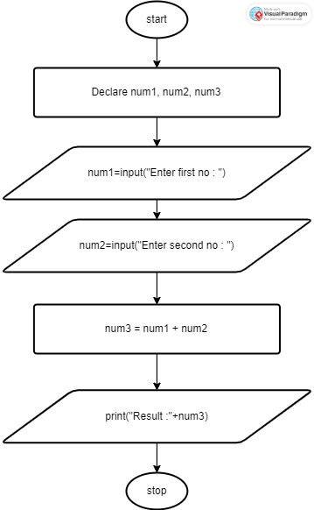

**4. Pseudo code**

//Declare

1. Declare num1 as integer
2. Declare num2 as integer
3. Declare num3 as integer

//Input

1. num1 = input(“Enter first no : “)
2. num2 = input (“Enter second no :”)

//Process

1. num3 = num1 + num2

//Output

1. print(“Sum : “+num3)

**5. Desk-check**

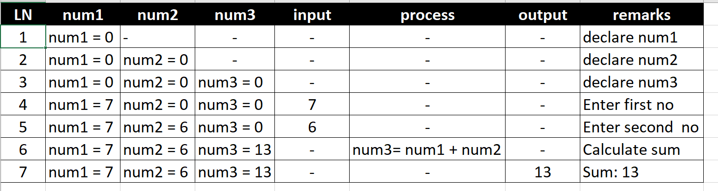

6. Source Code

7. Output

8. Conclusion